ALI DTV SUBTITLE SDK DEVELOPER’S GUIDE

Revision History

Revision | Author | Date | Comments
0.1 | Leal Lian | December 19, 2007 | Created
0.2 | Leal Lian | January 21, 2009 | Update

CONTENTS

INTRODUCTION 4
Abbreviations 4
Audience for This Guide 4
Guide Organization 4
Additional Resources 5
DVB subtitle SDK 5
DVB subtitle parsing 6
Display set Information get and Render 7
Appendix A: Function Reference 7
ALI_DTV_SUB_Create 7
ALI_DTV_SUB_Release 8
ALI_DTV_SUB_Push_PES_Pkt 8
ALI_DTV_SUB_Get_Region_Count_Of_DS 9
ALI_DTV_SUB_Get_Time_Out_Of_DS 9
ALI_DTV_SUB_Get_Region_Info 9
ALI_DTV_SUB_Region_Render_Context_Create 10
ALI_DTV_SUB_Region_Actual_Rendering 11
ALI_DTV_SUB_Region_Render_Context_Destroy 11
ALI_DTV_SUB_Display_Set_Destroy 11
Appendix B: Structure Reference 12
region_info 12
Appendix C: Callback Reference 12
DisplaySetRecv_CB 12
DrawHLine_CB 13
DrawString_CB 13
ColorSet_CB 14

INTRODUCTION
Welcome to the ALI DTV subtitle Software Development Kit (SDK), which ALLIN has created for developers working for DVB subtitle (ETSI EN 300 743). ALLIN provides the most sophisticated system available for digital TV implementation. This developer’s guide will help you use the SDK to integrate DVB subtitle support in your DTV applications and architectures.

Abbreviations
For the purposes of the present document, the following abbreviations apply:
DVB Digital Video Broadcasting
TS Transport stream
ALI All in
PID Packet Identifier
PTS Presentation Time Stamp, as defined in ISO/IEC 13818-1 [1]
PES Packetized Elementary Stream, as defined in ISO/IEC 13818-1 [1]
CLUT Colour Look-Up Table

Audience for This Guide
This guide is intended for experienced software developers who are interested in extending the
DTV capabilities of your application or platform architecture by adding support for DVB subtitle formats. Although the SDK was developed to meet the needs of those in resource-constrained environments, the Software Development Kit is aimed at developers of multimedia applications and architectures on any popular platform.

Guide Organization
This developer’s guide contains the following chapters and appendices.
Chapter 1: DVB subtitle SDK
An introduction to DVB subtitle SDK. This chapter provides general instructions on how to program with the SDK, It also includes information on accessing the structures provided with this SDK.
Chapter 2: DVB subtitle parsing
Describes the process of reading and decoding subtitle PES packets. This chapter also includes method for receiving the ready display sets.
Chapter 3: Display set Information get and Render
Discusses how to get information of the display set and how to render it.
Appendix A: Function Reference
This appendix provides descriptions of the functions supplied with the DVB SUB SDK.
Appendix B: Structure Reference
This appendix provides descriptions of the structures supplied with the DVB SUB SDK.
Appendix C: Callback Reference
This appendix provides descriptions of the callbacks supplied with the DVB SUB SDK.

Additional Resources
In addition to this manual, you may need the following documentation resources:
- ISO/IEC 13818-1: "Information technology - Generic coding of moving pictures and associated audio information: Systems"
- ETSI EN 300 468: "Digital Video Broadcasting (DVB); Specification for Service Information (SI) in DVB systems".
- ETSI EN 300 743: "Digital Video Broadcasting (DVB); Subtitling systems".
- ALI SVP SDK developer’s guide
- ALI Teletext SDK developer’s guide

DVB subtitle SDK
The DVB subtitle Software Development Kit (SDK) provides developers with the functions, structures, and callbacks used to extend support for DVB subtitle to your applications. This chapter provides a brief overview of the steps required to process and render DVB subtitle stream.

In general, you would use the following steps to process and render a DVB subtitle stream.
- Create and initialize ALI DVB subtitle parser;
- Push the standard DVB subtitle PES packets to parser for decoding;
- Use Callback functions receiving the ready display sets(subtitle pages);
- Get basic information from ready display set, determine that if this display set can be rendered and how long will be displayed, also need get how many regions in it and each region’s information;
- Create one region render context, fill callback functions, implement actual rendering for this region and destroy this context after rendering, then make same process step to other regions;
- Release and clean up the ALI DVB subtitle parser.

The following figure illustrates these steps:
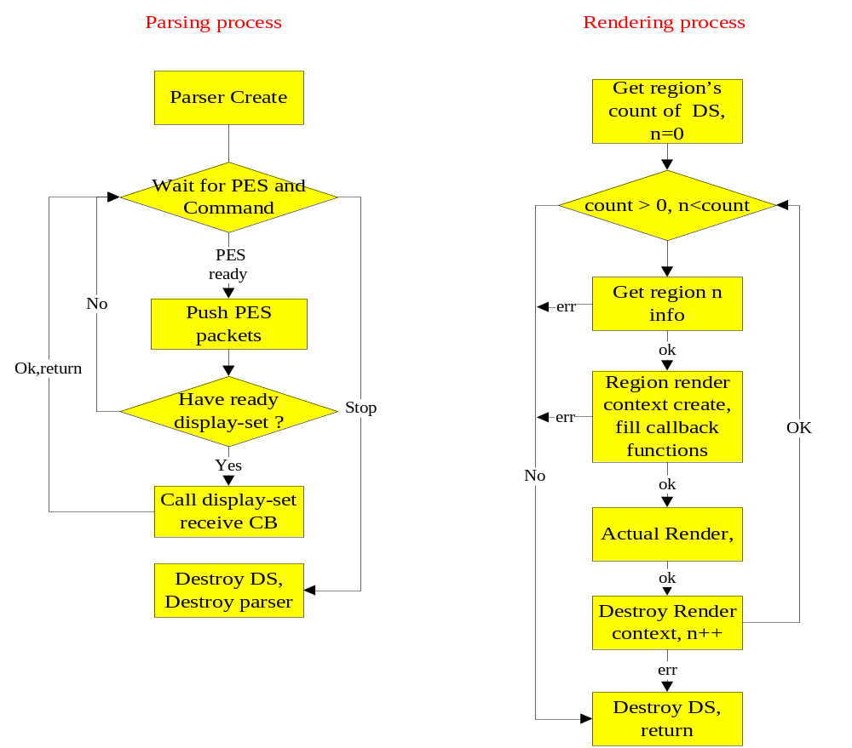
- Figure 1: process

DVB subtitle parsing
After create the ALLIN subtitle parser(call API “ALI_DTV_SUB_Create()”), you can use it decoding DVB subtitle stream. Please note the subtitle source for decoding are standard PES packets. Because one subtitle stream may be includes many type pages and ancillary page, you must set the page ID which you are interesting. A callback function (“display_set_recv_cb”) will be registered when parser created, this callback is be used for receiving the ready display sets and it’s PTS. After you push the PES packet(call API “ALI_DTV_SUB_Push_PES_Pkt()”), the parser will handle all segments in it and judge if have ready display set for rendering, if have, parser will call the display set receiving callback routine, if you want to destroy parser, please call API “ALI_DTV_SUB_Release()”, please don’t forget call “ALI_DTV_SUB_Display_Set_Destroy()” API destroy all display sets you received

Display set Information get and Render
You have got some display set and one’s display time has come (judge from PTS of display set), you can use our APIs rendering it. The basic principle is you provide callback functions and SDK render the display set, you needn’t know the detail, and “region” is the least unit for rendering, one display set may be have more “region”, these region must be handled one by one.
First step, you must check to ensure that this display set have regions for rendering, use “ALI_DTV_SUB_Get_Region_Count_Of_DS()” API get the region’s total number, if the result is zero, the display set must destroy.
Secondly, some callback functions need prepare, the first is “set color” and this function will be called for creating your color map table (the color in this table is the real color for rendering, because default CLUT use Ycbcr but popular OSD use RGB, and also 2-bit/4-bit color need map to 8-bit color for almost devices). The second is “draw horizontal line” and this function will be called when render actually, another function “draw string” for display the character format subtitle.
Thirdly, get this region’s information using API “ALI_DTV_SUB_Get_Region_Info()” (such as horizontal/ vertical address, width/height and background color), use these information design you private structure (for example display buffer size and color map table), and then create region render context using API “ALI_DTV_SUB_Region_Render_Context_Create()”, then call “ALI_DTV_SUB_Region_Actual_Rendering()” API render this region, if you set callback function correctly, the display buffer will be filled correctly, after rendering you must call API “ALI_DTV_SUB_Region_Render_Context_Destroy()” release the render context. If have other “region” for rendering, please repeat this step.
Finally, call API “ALI_DTV_SUB_Display_Set_Destroy()” destroy this display set you rendered.

Appendix A: Function Reference

ALI_DTV_SUB_Create
Header File： ALI_DTV_SUB_api.h
/**
* ALI_DTV_SUB_Create:
* @ page_id: IN, ID of a page that SUB module should handle.
* @ ancillary_page_id: IN, ID of a ancillary page that SUB module should handle.
* @ ds_recv_cb: IN, Callback function to call when page is ready to be displayed,
* a ready display set will be pushed and the PTS is also provided
* @ ds_recv_priv: IN, Private data for callback.
*
*
* Description: Create & Init the SUB module;
*
* Returns: NULL, error
* !NULL, SUBHandle
*/
HANDLE ALI_DTV_SUB_Create(int page_id,
Int ancillary_page_id,
display_set_recv_cb ds_recv_cb,
void* ds_recv_priv);

ALI_DTV_SUB_Release
Header File： ALI_DTV_SUB_api.h
/**
* ALI_DTV_SUB_Release:
* @ SUBHandle: IN, the context ptr of SUB module
*
* Description: Release the SUB module;
*
* Returns: -1, error
* 0, ok
*
*/
int ALI_DTV_SUB_Release(HANDLE SUBHandle);

ALI_DTV_SUB_Push_PES_Pkt
Header File： ALI_DTV_SUB_api.h
/**
* ALI_DTV_SUB_Push_PES_Pkt:
* @ SUBHandle: IN, the context ptr of SUB module
* @ pkt: IN, the PES buffer to decode.
* @ max_size: IN, the max size of the pkt buffer.
*
* Description: push sub PES packet to ALI SUB moudle;
* Note: the display_set_recv_cb will be call back when one page ready
*
* Returns: -1, error
* 0, ok
*/

int ALI_DTV_SUB_Push_PES_Pkt(HANDLE SUBHandle,
char* pkt, ,int max_size);

ALI_DTV_SUB_Get_Region_Count_Of_DS
Header File： ALI_DTV_SUB_api.h
/**
* ALI_DTV_SUB_Get_Region_Count_Of_DS:
* @ SUBHandle: IN, the context ptr of SUB module
* @ display_set: IN, the ready display set.
*
* Description: get the number of regions of this display set
*
* Returns: -1, error
* >=0, ok
*/
int ALI_DTV_SUB_Get_Region_Count_Of_DS(HANDLE SUBHandle,
void* display_set);

ALI_DTV_SUB_Get_Time_Out_Of_DS
Header File： ALI_DTV_SUB_api.h
/**
* ALI_DTV_SUB_Get_Time_Out_Of_DS:
* @ SUBHandle: IN, the context ptr of SUB module
* @ display_set: IN, the ready display set.
*
* Description: get the time out seconds of this display set
*
* Returns: -1, error
* >=0, Maximum time to show this page in seconds
*/
int ALI_DTV_SUB_Get_Time_Out_Of_DS(HANDLE SUBHandle,
void* display_set);

ALI_DTV_SUB_Get_Region_Info
Header File： ALI_DTV_SUB_api.h
/**
* ALI_DTV_SUB_Get_Region_Info:
* @ SUBHandle: IN, the context ptr of SUB module
* @ display_set: IN, the ready display set.
* @ region: IN/OUT, the ptr of struct region_info will be filled.
* @ region_index: IN, the index of region want to find.
*
* Description: get the region info of display set from index
*
* Returns: -1, error
* >=0, ok
*/
int ALI_DTV_SUB_Get_Region_Info(HANDLE SUBHandle,
void* display_set,
region_info* region,
unsigned int region_index);

ALI_DTV_SUB_Region_Render_Context_Create
Header File： ALI_DTV_SUB_api.h
/**
* ALI_DTV_SUB_Region_Render_Context_Create:
* @ SUBHandle: IN, the context ptr of SUB module
* @ display_set: IN, the ready display set.
* @ region_id: IN, the ID of the region you want to render.
* @ hline_callback: IN, function to draw a horizontal line (may be NULL)
* @ string_callback: IN, function to draw a string (may be NULL)
* @ set_color_callback: IN, function to map pseudo color to display color
* @ priv: IN, private data to callback functions
*
* Description: Create a rendering context of a region
*
* Returns: !NULL, the Context
* NULL, err
*/
void* ALI_DTV_SUB_Region_Render_Context_Create
( HANDLE SUBHandle,
void* display_set, unsigned int region_id, dvbsub_hline_function_t hline_callback,
dvbsub_draw_string_function_t string_callback,
dvbsub_set_color_function_t set_color_callback,
void *priv);

ALI_DTV_SUB_Region_Actual_Rendering
Header File： ALI_DTV_SUB_api.h
/**
* ALI_DTV_SUB_Region_Actual_Rendering:
* @ SUBHandle: IN, the context ptr of SUB module
* @ ctxt: IN, the context ptr of region render.
*
* Description: Actual Rendering of this region
*
* Returns: -1, error
* >=0, ok
*/
int ALI_DTV_SUB_Region_Actual_Rendering(HANDLE SUBHandle,void* ctxt);

ALI_DTV_SUB_Region_Render_Context_Destroy
Header File： ALI_DTV_SUB_api.h
/**
* ALI_DTV_SUB_Region_Render_Context_Destroy:
* @ SUBHandle: IN, the context ptr of SUB module
* @ ctxt: IN, the context ptr of region render.
*
* Description: Destroy the render context
*
* Returns: -1, error
* >=0, ok
*/
Int ALI_DTV_SUB_Region_Render_Context_Destroy(HANDLE SUBHandle,void* ctxt);

ALI_DTV_SUB_Display_Set_Destroy
Header File： ALI_DTV_SUB_api.h
/**
* ALI_DTV_SUB_Display_Set_Destroy:
* @ SUBHandle: IN, the context ptr of SUB module
* @ display_set: IN, the display set will be handle.
*
* Description: Destroy this display set
*
* Returns: -1, error
* >=0, ok
*/
int ALI_DTV_SUB_Display_Set_Destroy(HANDLE SUBHandle, void* display_set);

Appendix B: Structure Reference

region_info
Header File： ALI_DTV_SUB_typedef.h
The information about one region in a display set
typedef struct{
unsigned int region_id;
unsigned int region_horizontal_address;
unsigned int region_vertical_address;
unsigned int region_width;
unsigned int region_height;
int bkcolor;
} region_info;

region_horizontal_address
Horizontal region composition position in page( 0..719)
region_vertical_address
Vertical region composition position in page(0..575)
bkcolor
background color for region. Value is either in range 0-255 for pseudo color

Appendix C: Callback Reference

DisplaySetRecv_CB
Header File： ALI_DTV_SUB_typedef.h
/*
* Function that receives ready display set and it's PTS.
* Parameters:
* priv: private data possibly meaningful to called function
* display_set: the display set received
* pts: the pts of display_set
*
*/
typedef void (*DisplaySetRecv_CB)(void *priv, void *display_set,UINT64 pts);

DrawHLine_CB
Header File： ALI_DTV_SUB_typedef.h
/*
* Draws a horizontal line.
* Parameters:
* priv: private data
* x, y: left ending point of a line
* length: line length
* thickness: line thickness (1 or 2), second line is drawn below the
* first line
* pseudo_color: references drawing color
*/
typedef void (*DrawHLine_CB)(void *priv, int x, int y, int length,
int thickness, unsigned char pseudo_color);

DrawString_CB
Header File： ALI_DTV_SUB_typedef.h
/*
* Draw a string.
* Parameters:
* priv: private data
* x, y: top left corner?
* width, height: maximum string width/height in pixels
* str: decoding a string is left to this function
* length: string length
* fgcolor: foreground color of characters
* bgcolor: background color of characters
*/
typedef void (*DrawString_CB)(void *priv, int x, int y, int width, int height, const unsigned short *str, int length,
unsigned char fgcolor, unsigned char bgcolor);

ColorSet_CB
Header File： ALI_DTV_SUB_typedef.h
/*
* Maps pseudo color to actual color
* Parameters:
* priv: private data
* pseudo_color: color to map
* Y, Cb, Cr: color components
* T: level of transparency (0=full transparency)
*/
typedef void (*ColorSet_CB)(void *priv, unsigned char pseudo_color,
unsigned char Y, unsigned char Cb, unsigned char Cr, unsigned char T);

